- Data Structure and definition :
The design of the File- Sharing Server is composed of 2 main parts:
the FileSystemManager which simulates the filesystem and the FileServer which provides the client interface over TCP.
These 2 modules operate without any overlap; the server takes care of accepting and processing commands and checking their validity, while the filesystem manager takes care of the actual file operations, such as create, delete, read, write etc. The directory part of the filesystem is implemented as a static-sized array of FEntry objects. Each FEntry object contains the metadata for a file, including the filename (max 11 chars) and the total file size in bytes, plus the index of the first block containing the file's data. This lightweight representation matches the specifications and allows the filesystem to know exactly where the file's data is located. FileSystemManager has several important fields; an array of FEntry objects representing the directory, a RandomAccessFile to represent the on-disk "virtual disk",and a read/write lock to synchronize the access to the filesystem from the different client threads.Constants for the block size and the number of blocks guarantee that the directory structure and the file data remain consistent in terms of layout. Block 0 will be always reserved for the metadata, while blocks 1 to 9 will be dedicated to the file contents. Therefore, the disk layout will be always organized in a predictable and straightforward manner.Some core methods are defined and describe the behavior of the filesystem. The createFile() method will assign a directory entry and will update the metadata to the disk. The writeFile() method will store the bytes of the file in continuous blocks and will update the FEntry related to this file. The readFile() method will load the content of the file into memory, while the deleteFile() method will remove the file and will zero-out the blocks occupied by the file. There is also a helper method called listFiles() that returns an array of filenames currently stored in the directory. Two private methods called writeMetadata() and loadMetadata() will ensure that the filesystem remains consistent by serializing/deserializing the directory structure from block 0.All of these methods will utilize the filesystem's read-write lock to ensure the safety of the interaction between multiple clients connected to the server. On the server-side, the FileServer class was designed to be lightweight. It will contain the port number and a reference to the shared instance of the FileSystemManager. Its start() method will open a ServerSocket and will create a new thread for each incoming client connection. In the handleClient() method, it will read exactly one command from each client connection, parse it safely by splitting at most 3 components, and will forward the execution of the corresponding action to the filesystem. Any errors, either due to invalid commands or due to filesystem-related issues, will be communicated back to the client using an "ERROR:" message, while valid actions will result in a "SUCCESS:" message being sent back to the client. Both parts create a clear and modular architecture, where the logic of the filesystem is completely encapsulated and the server deals only with networking and request parsing.

- UML diagram :
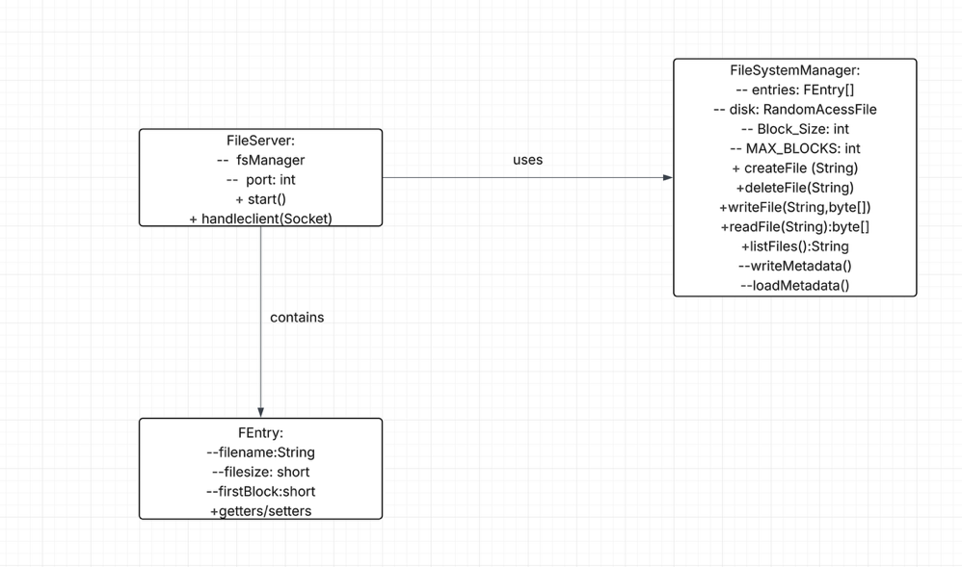
UML diagram (-- means private; + means public)
- Algorithm :
This section describes the key steps taken when a client requests that a file be created, the key steps taken when a client wishes to write to an existing file, the key steps taken when a client requests a read of an existing file, the key steps taken when a client requests deletion of a file, the key steps taken when a client requests a listing of files on the system, and finally the steps taken by the server to service a given client request.
When a client wishes to create a file, the client sends a Create command to the server. In response, the server creates a write lock so that it may have the exclusive right to perform this action. It verifies that the file does not already exist and finds the next available slot in the FEntry array. It creates the file entry and sets it to the default metadata for the file type; it updates the directory in Block 0 to include the new file; and it then releases the write lock. If there is no room left in the FEntry array, an exception will occur. These actions are simple, yet they provide the needed protection against loss of synchronization between the different parts of the program.
A Write is the algorithm that provides the necessary support to store the content of the file in a series of contiguous Blocks. First, it gets a write lock to allow it to update the file exclusively. Next, it verifies that the file was previously successfully created. It then determines how many Blocks it needs to use to hold the content of the file, and it searches through the Blocks in the order of Block 1 through Block 9 to determine which group of contiguous Blocks has sufficient space to contain all of the content of the file. If it finds a group of contiguous Blocks that is large enough to hold the content of the file, it writes each Block in sequence and pads the last Block with zeros to fill any unused space. Finally, it updates the file's Entry with the correct length of the file and the address of the first Block of the file. Before closing, the algorithm writes the changed metadata to disk. If it cannot find a group of contiguous Blocks of sufficient size, it throws an exception. Thus, while the algorithm takes care of managing the Blocks in a way that is both predictable and easy to manage, it also allows the user to specify how much space to allocate for the file when the file is created.
A Read is the algorithm that accesses the content of a file in the manner described above. A Read is performed under a read lock so that other Readers may access the File System at the same time. It determines how many Blocks the file spans, it reads the Blocks in sequential order from the Disk, and it passes the content of the file back to the Client. An empty file is passed back as an empty byte array. Also, since the metadata is always kept consistent, if the metadata contains incorrect information about the file, the algorithm throws an exception.
The Delete Algorithm is used to remove a File from the File System. To do this, it gets a write lock to prevent anyone else from accessing the File System during the removal process, it checks to see if the File exists, it clears each Block that is being used by the file, it removes the File Entry from the Directory, it writes the changes made to the File System back to the Disk, and it releases the write lock. As a result, both the metadata associated with the file, and the actual content of the file are removed in a safe manner.
Finally, the List Algorithm is the easiest of the five algorithms described here. It is done under a read lock to allow multiple Readers to access the File System simultaneously. It iterates over the Entries in the Directory, it adds the names of any Files that are not null to the list of Files it is building, and it returns the completed list of Files. If the File System is empty, it returns an empty list.
As mentioned earlier, the Server is designed to be very simple. Each Client Connection is serviced by a separate thread running on the Server. Once a Client establishes a Connection with the Server, the Server reads a single line of text from the Client, breaks down the Request into Tokens, and performs the Action specified in the Request (Create, Write, Read, Delete, List, Quit). Any errors encountered during the execution of the Request (such as missing Arguments or Unknown Commands) are handled in a graceful manner. After sending one Response to the Client, the Server closes the Client Connection. The "One Command Per Connection" Model of processing Client Requests matches the Professor's Test Harness and makes it much easier to handle Concurrent Requests from multiple Clients.

- Rationale :
This section outlines the fundamental processes involved with creating a file per the client’s request, writing to a file per the client’s request, reading an existing file per the client’s request, deleting a file per the client’s request, listing files on the system per the client’s request, and the server servicing a particular client request.
If the client desires to create a file, the client will send a Create command to the server. The server will create a write lock so it can execute this action alone. It will verify that the file does not currently exist and locate the next available position in the FEntry array. The server will add a file entry to the FEntry array, set it to the default file metadata, and update the directory in block 0 with the new file. The server will release the write lock. If the FEntry array is completely full, an exception will be thrown. This example illustrates the simplicity of these commands while still maintaining the integrity of protecting against de-synchronization of the various components of the software.
The Write algorithm provides the necessary support to record the contents of the file into a series of consecutive blocks. The Write algorithm starts by obtaining a write lock to enable it to make updates to the file without interference from others. Next, it validates that the file was previously successfully created. The Write algorithm will then determine how many blocks are required to hold the contents of the file, and search through the blocks starting with block 1 and ending with block 9 to identify the first sequence of consecutive blocks having enough space to contain the entire file. Once it identifies a sequence of consecutive blocks having enough space to contain the file, the Write algorithm will write each block in sequence and pad the final block with zeros to fill any remaining space. Finally, the Write algorithm will update the file entry to indicate the length of the file and the location of the first block of the file. Prior to terminating, the Write algorithm will write any updated metadata to disk. If it is unable to identify a sequence of consecutive blocks having enough space to contain the file, the Write algorithm will throw an exception. While the Write algorithm manages the blocks in a predictable and manageable manner, it allows users to specify the amount of space allocated to the file when it is created.
The Read algorithm accesses the file contents as outlined above. When performing a Read operation, the Read algorithm executes under a read lock allowing other Readers to access the File System concurrently. The Read algorithm will determine how many blocks the file extends across, read the blocks sequentially from the Disk, and pass the contents of the file back to the Client. When the file is empty, the Read algorithm will pass back an empty byte array. Additionally, due to the fact that the metadata is always maintained consistently, the Read algorithm will throw an exception if the metadata indicates incorrect information regarding the file.
The Delete Algorithm is utilized to eliminate a File from the File System. The Delete Algorithm begins by acquiring a write lock to protect against other clients attempting to access the File System while the deletion is taking place, then determines if the File exists, then deletes each block being used by the file, removes the File Entry from the Directory, writes the modifications made to the File System to Disk, and releases the write lock. Therefore, both the metadata associated with the file, and the actual contents of the file, are safely deleted.
Finally, the List Algorithm is the most straightforward of the five algorithms described above. The List Algorithm is executed under a read lock, enabling multiple Readers to access the File System at the same time. The List Algorithm iterates through the entries in the Directory, includes the names of any files that are not null in the list of files being generated, and returns the completed list of files. If the File System is empty, the List Algorithm will return an empty list.
As stated previously, the Server is designed to be very simple. Each Client Connection is processed via a separate thread operating on the Server. Upon establishing a connection with the Server, the Server will read one line of text from the Client, break the Request into tokens, and perform the action requested by the Client (Create, Write, Read, Delete, List, Quit). Any errors encountered by the Server while executing the Request (for example, missing arguments or unknown commands) will be processed in a smooth manner. Following the transmission of one Response to the Client, the Server will terminate the Client Connection. The “one command per connection” model of processing Client Requests enables the Server to operate with the Test Harness provided by the Professor, and greatly simplifies handling concurrent requests from multiple Clients.

